Name: ____________________________________________________________ Date: _______________ Period: ________
Chapter A2 – Weather Patterns: Study Guide/Review Sheet
Vocabulary:

_______________________________ | - The force of air molecules pressing on an area
_______________________________ | - The condition of Earth’s atmosphere at a certain time and place
_______________________________ | - Wind patterns that flow thousands of km over Earth
_______________________________ | - When water changes from a liquid to a gas
_______________________________ | - When water changes from a gas to a liquid
_______________________________ | - Any form of liquid or solid water that falls from the sky
_______________________________ | - The amount of water vapor in the air
_______________________________ | - The temperature at which the air is saturated with water vapor
_______________________________ | - The influence of Earth’s rotation on winds
_______________________________ | - Air that moves horizontal to the ground.

Short Answer:
- Wind moves from areas of ____________ pressure to areas of _________________ pressure.
- What tool is used to measure air pressure? __________________________
- Clouds form when ___________ air rises, ____________, and condenses on ________________.
- Relative humidity compares the amount of water vapor in the air to the _________________ amount of water vapor in the air.
- Air that sinks is _________________ than the surrounding air.
- ____________________________ clouds are most likely to bring thunderstorms.
- The two calm regions that separate wind belts are called the ______________________ and the ______________________________.
- We live in the _________________________ layer of the atmosphere.

True/False. Circle whether you each statement is true or false. If it is false, underline the part that is incorrect.
- Wind is caused by uneven heating of Earth’s surface causing pressure differences. _____________
- Cold air has a lower pressure than warm air. _____________
- As density of the air decreases, air pressure decreases. _____________
- As altitude increases, air pressure decreases. _____________
- Large pressure differences between areas cause strong, fast winds. _____________
- Cirrus clouds form in warm areas close to Earth’s surface. _____________
- Freezing rain is rain that freezes when it hits the ground, while sleet freezes as it falls. _________
Vocabulary (Clouds and Precipitation):
_______________________________ | - Forms when ice pellets move up and down in clouds, gaining layers of ice.
_______________________________ | - The most common form of precipitation
_______________________________ | - Type of cloud that forms in layers; smooth.
_______________________________ | - Type of precipitation that forms from ice crystals merging in clouds
_______________________________ | - A cloud that rests on the ground or water
_______________________________ | - Rain that freezes when it hits the ground or other surfaces
_______________________________ | - Type of cloud that are puffy with darker bases.
_______________________________ | - Type of cloud that forms in very cold air at high altitudes.
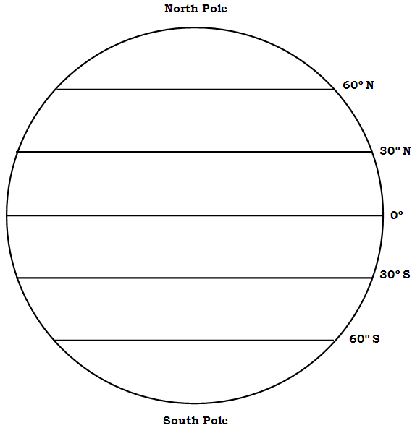
Wind Patterns: On the diagram to the right, label:
- Trade winds
- Westerlies
- Polar Easterlies
- Horse Latitudes
- Doldrums
- Circulation Cell

Part 6: Short Answer.
- Describe the steps of the water cycle.

